**..**

**PHISHING DETECTION**

**A MINI PROJECT REPORT**

***Submitted by***

|  |  |
| --- | --- |
| **PREM ROSHAN P** | **231901036** |
| **LAKSHMINARAYANAN K** | **231901027** |
| **ARAVIND S** | **231901006** |

***in partial fulfillment of the award of the degree of***

**BACHELOR OF ENGINEERING IN**

**COMPUTER SCIENCE AND ENGINEERING**



**RAJALAKSHMI ENGINEERING COLLEGE, CHENNAI**

# An Autonomous Institute

CHENNAI APRIL 2025

**BONAFIDE CERTIFICATE**

Certified that this project **“PHISHING DETECTION”** is the bonafide work of **“PREM ROSHAN P, LAKSHMI NARAYANAN K, ARAVIND S”** who carried out the project work under my supervision.

|  |
| --- |
| **SIGNATURE** |
| **Mrs. V JANANEE** |
| **ASSISTANT PROFESSOR** |
|  |
| Dept. of Computer Science and Engg, |
| Rajalakshmi Engineering College  Chennai |

This mini project report is submitted for the viva voce examination to be held on

**INTERNAL EXAMINER EXTERNAL EXAMINER**

**ABSTRACT**

Phishing attacks are a major threat to internet users, aiming to steal sensitive information such as login credentials, bank details, and personal data by impersonating trusted entities. Attackers create fake websites or send fraudulent emails that appear legitimate, making it difficult for users to distinguish between genuine and malicious communications. As the number of phishing incidents continues to grow, there is a pressing need for an effective and user-friendly detection system.

This project proposes a Phishing Detection System that identifies phishing threats based on rule-based analysis and URL inspection techniques. Instead of relying on complex machine learning models, the system utilizes a set of predefined rules and feature checks to detect suspicious patterns in URLs. Some of the features analyzed include URL length, presence of special characters such as '@' or '-', use of IP addresses instead of domain names, multiple redirects, and whether the website uses HTTPS encryption. By evaluating these characteristics, the system can make a quick decision about the likelihood of a URL being malicious.

**ACKNOWLEDGEMENT**

We express our sincere thanks to our beloved and honorable chairman **MR. S. MEGANATHAN** and the chairperson **DR. M. THANGAM MEGANATHAN** for their timely support and encouragement. We are greatly indebted to our respected and honorable principal **Dr. S.N. MURUGESAN** for his able support and guidance. No words of gratitude will suffice for the unquestioning support extended to us by our Head Of The Department **Mr. BENIDICT JAYAPRAKASH NICHOLAS** for being an ever-supporting force during our project work. We also extend our sincere and hearty thanks to our internal guide **Mrs.V JANANEE** for her valuable guidance and motivation during the completion of this project. Our sincere thanks to our family members, friends, and other staff members of computer science engineering.

1. **PREM ROSHAN P**
2. **LAKSHMI NARAYANAN K**
3. **ARAVIND S**

**TABLE OF CONTENTS**

|  |  |  |
| --- | --- | --- |
| **CHAPTER NO** | **TITLE** | **PAGE NO** |
| **1** | **INTRODUCTION** | **7** |
| **1.1** | Introduction | **7** |
| **1.2** | Scope of the Work | **7** |
| **1.3** | Problem Statement | **7** |
| **1.4** | Aim and Objectives of the Project | **7** |
| **2** | **SYSTEM SPECIFICATIONS** | **8** |
| **2.1** | Hardware Specifications | **8** |
| **2.2** | Software Specifications | **8** |
| **3** | **MODULE DESCRIPTION** | **9** |
| **4** | **CODING** | **10** |
| **5** | **SCREENSHOTS** | **16** |
| **6** | **CONCLUSION AND FUTURE ENHANCEMENT** | **17** |
| **7** | **REFERENCES** | **18** |

**LIST OF FIGURES**

**Figure No. Title Page No.**

5.1 Home Page 15

5.2 URL Input and Result Display Page 15

5.3 URL Feature Extraction Example 16

5.4 Rule-based URL Analysis Flowchart 16

5.5 Warning Message for Suspicious URL 17

5.6 Database of Blacklisted URLs 17

**CHAPTER 1**

**INTRODUCTION**

* 1. **INTRODUCTION**

Phishing is a deceptive technique where attackers attempt to gather personal information by imitating trusted sources. Victims are tricked into clicking on malicious links or filling out fake forms. To counter this, the project proposes a real-time Phishing Detection System that uses rule-based logic to assess a given URL's authenticity and check the host system’s behavior. This tool is essential for everyday users who might lack the technical know-how to identify phishing threats. It enhances security by offering a proactive way to evaluate suspicious links.

* 1. **SCOPE OF THE WORK**

The scope of the work encompasses the development of a comprehensive system designed to detect phishing URLs in real-time using non-machine learning (non-ML) rule sets. This system will also include live monitoring of critical system resources such as CPU usage, memory consumption, and disk activity to ensure optimal performance. Additionally, it will generate risk scores based on multiple factors to assess the severity of detected threats. To enhance usability, the system will feature a user-friendly interface, enabling seamless interaction for users of varying technical expertise

* 1. **AIM AND OBJECTIVES OF THE PROJECT**

# Aim:

To develop a phishing URL detection system using rule-based feature analysis for accurate identification of malicious websites.

# Objectives:

* + - Detect phishing URLs using rule-based feature analysis
    - Monitor system resources (CPU, memory) during scans.
    - Generate user-friendly risk reports.

**CHAPTER 2**

**SYSTEM SPECIFICATIONS**

* 1. **HARDWARE SPECIFICATIONS**

|  |  |
| --- | --- |
| Component | **:** Specification |
| Processor | **:** Dual core or Higher |
| RAM | **:** 8 GB (Minimum) |
| Storage | :256 GB SSD / 1 TB HDD |

* 1. **SOFTWARE SPECIFICATIONS**

|  |  |
| --- | --- |
| Operating System | **:** Windows/Linux/MacOS |
| Dependencies | **:** psutil, tkinter, matplotlib |
| Visualization | **:** GUI |
| Languages Used | **:** Python 3.7+ |
| Libraries  Tools | : Flask, psutil,pandas, numpy, etc.  : VS Code, browser (Chrome/Firefox) |

**FLOW DIAGRAM**

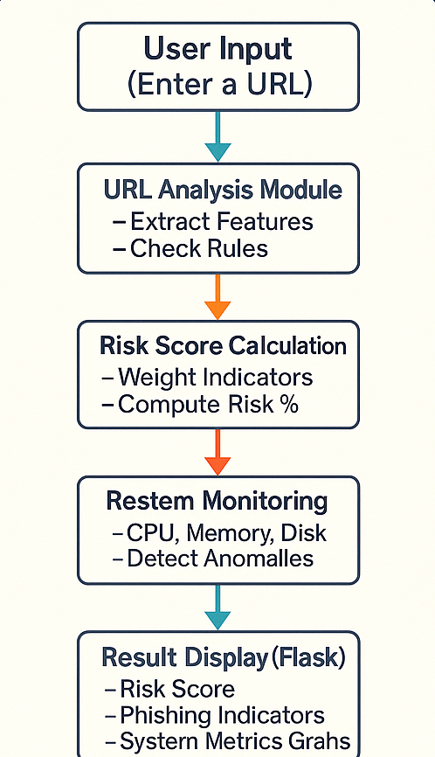

**CHAPTER 3**

**MODULE DESCRIPTION**

# URL ANALYSIS MODULE

* Accepts user input (URL) for inspection.
* Extracts URL components such as domain, subdomain, path, and query.
* Suspicious or uncommon Top-Level Domains (TLDs)
* IP address usage instead of domain names.

# System Monitoring Module

* Uses psutil to gather process data:
* CPU usage percentage.
* Memory (RAM) usage percentage.
* Disk storage usage percentage.
* Detects abnormal system behavior (high CPU/memory usage) during phishing checks.

# Risk Score Calculation Module

* Assigns weighted scores based on phishing indicators.
* Computes an overall risk score for the submitted URL.
* Flags URLs as safe, suspicious, or highly risky based on the final score.

# Web Application Module (Flask)

* Provides a user-friendly web interface.
* Allows users to input URLs and view analysis results.
* Displays real-time system metrics through interactive graphs.
* Returns phishing indicators and the risk score in an easily understandable format.

**CHAPTER 4**

**SOURCE CODE:**

# main.py

from flask import Flask, render_template, jsonify, request

from flask_cors import CORS

import psutil

import re

from urllib.parse import urlparse

from datetime import datetime

app = Flask(__name__)

CORS(app)

def get_system_metrics():

cpu_percent = psutil.cpu_percent(interval=1)

memory = psutil.virtual_memory()

disk = psutil.disk_usage('/')

return {

'cpu_usage': cpu_percent,

'memory_usage': memory.percent,

'disk_usage': disk.percent,

'timestamp': datetime.now().strftime('%Y-%m-%d %H:%M:%S')

}

def analyze_phishing_indicators(url, system_metrics):

try:

if not url.startswith(('http://', 'https://'))

url = 'http://' + url

parsed_url = urlparse(url)

domain = parsed_url.netloc.lower()

path = parsed_url.path.lower()

query = parsed_url.query.lower()

except Exception:

domain = url.lower()

path = ''

query = ''

legitimate_tlds = {'.com', '.org', '.net', '.edu', '.gov', '.mil', '.int', '.eu', '.us', '.uk', '.ca', '.au', '.de', '.fr', '.jp'

suspicious_tlds = {'.xyz', '.tk', '.ml', '.ga', '.cf', '.gq', '.pw', '.cc', '.top', '.work', '.party', '.date', '.stream', '.racing', '.win', '.bid', '.loan'}

tld = '.'+domain.split('.')[-1] if '.' in domain else ''

brand_names = {

'google': 'google.com',

'facebook': 'facebook.com',

'microsoft': 'microsoft.com',

'apple': 'apple.com',

'amazon': 'amazon.com',

'paypal': 'paypal.com',

'netflix': 'netflix.com',

'instagram': 'instagram.com',

'twitter': 'twitter.com',

'linkedin': 'linkedin.com'

}

indicators = {

'suspicious_tld': (tld in suspicious_tlds) or (tld not in legitimate_tlds),

'ip_address': bool(re.match(r'^(?:[0-9]{1,3}\.){3}[0-9]{1,3}(?::[0-9]+)?$', domain)),

'suspicious_ports': ':' in domain and domain.split(':')[-1].isdigit() and int(domain.split(':')[-1]) not in [80, 443],

'system_anomaly': system_metrics['cpu_usage'] > 90 or system_metrics['memory_usage'] > 90,

'long_url': len(url) > 100,

'suspicious_chars': bool(re.search(r'[0-9]|[-]', domain.split('.')[0])) if '.' in domain else False,

'multiple_subdomains': domain.count('.') > 2,

'suspicious_keywords': any(keyword in (path + query) for keyword in [

'login', 'signin', 'verify', 'account', 'secure', 'update', 'password',

'confirm', 'verification', 'authenticate', 'wallet', 'security'

]),

'brand_impersonation': any(

brand in domain and brand_names[brand] not in domain

for brand in brand_names

),

'special_chars': bool(re.search(r'[^a-zA-Z0-9.-]', domain)),

'numeric_domain': bool(re.search(r'^[0-9]+', domain.split('.')[0])),

'suspicious_patterns': bool(re.search(r'(secure|login|account|update|verify)[0-9]', domain))

}

weights = {

'suspicious_tld': 0.25,

'ip_address': 0.15,

'suspicious_ports': 0.10,

'system_anomaly': 0.05,

'long_url': 0.05,

'suspicious_chars': 0.10,

'multiple_subdomains': 0.05,

'suspicious_keywords': 0.10,

'brand_impersonation': 0.20,

'special_chars': 0.10,

'numeric_domain': 0.10,

'suspicious_patterns': 0.15

}

risk_score = sum(indicators[key] * weights[key] for key in weights) * 100

risk_score = min(max(risk_score, 0), 100)

high_risk_count = sum(1 for key in ['suspicious_tld', 'ip_address', 'brand_impersonation', 'suspicious_patterns'] if indicators[key])

if high_risk_count >= 2:

risk_score = min(risk_score * 1.5, 100) # Increase score by 50% if multiple high-risk indicators

return indicators, risk_score

@app.route('/')

def index():

return render_template('index.html')

@app.route('/api/system-metrics')

def system_metrics():

return jsonify(get_system_metrics())

@app.route('/api/analyze', methods=['POST'])

def analyze_url():

data = request.json

url = data.get('url', '')

system_metrics = get_system_metrics()

try:

indicators, risk_score = analyze_phishing_indicators(url, system_metrics)

return jsonify({

'indicators': indicators,

'risk_score': risk_score,

'system_metrics': system_metrics,

'analyzed_url': url

})

except Exception as e:

return jsonify({

'error': str(e),

'risk_score': 0,

'system_metrics': system_metrics

}), 400

if __name__ == '__main__':

app.run(debug=True)

# run.py

from app import app

if __name__ == '__main__':

print("Starting Flask application...")

app.run(debug=True, port=5000)

# process_monitor

import psutil

def get_processes(): processes = []

for proc in psutil.process_iter(['pid', 'name', 'memory_info']): try:

pid = proc.info['pid'] name = proc.info['name']

mem_info = proc.info['memory_info'] ram_mb = mem_info.rss / 1024 / 1024 ram_pct = proc.memory_percent()

cpu_pct = proc.cpu_percent(interval=None)

processes.append(( pid,

name, round(ram_mb, 2),

round(ram_pct, 3),

round(cpu_pct, 2)

))

except (psutil.NoSuchProcess, psutil.AccessDenied, psutil.ZombieProcess): continue

return processes

# simple_app.py

from flask import Flask

app = Flask(__name__)

@app.route('/')

def hello():

return 'Hello, World!'

if __name__ ='__main__':

print("Starting simple Flask application...")

app.run(debug=Trueport=5000)

**requirements .txt**

flask==2.0.1

psutil==5.8.0

pandas==1.3.3

numpy==1.21.2

scikit-learn==0.24.2

requests==2.26.0

python-dotenv==0.19.0

flask-cors==3.0.10

**CHAPTER 5 SCREENSHOTS**

**4. PHISHING DETECTION**

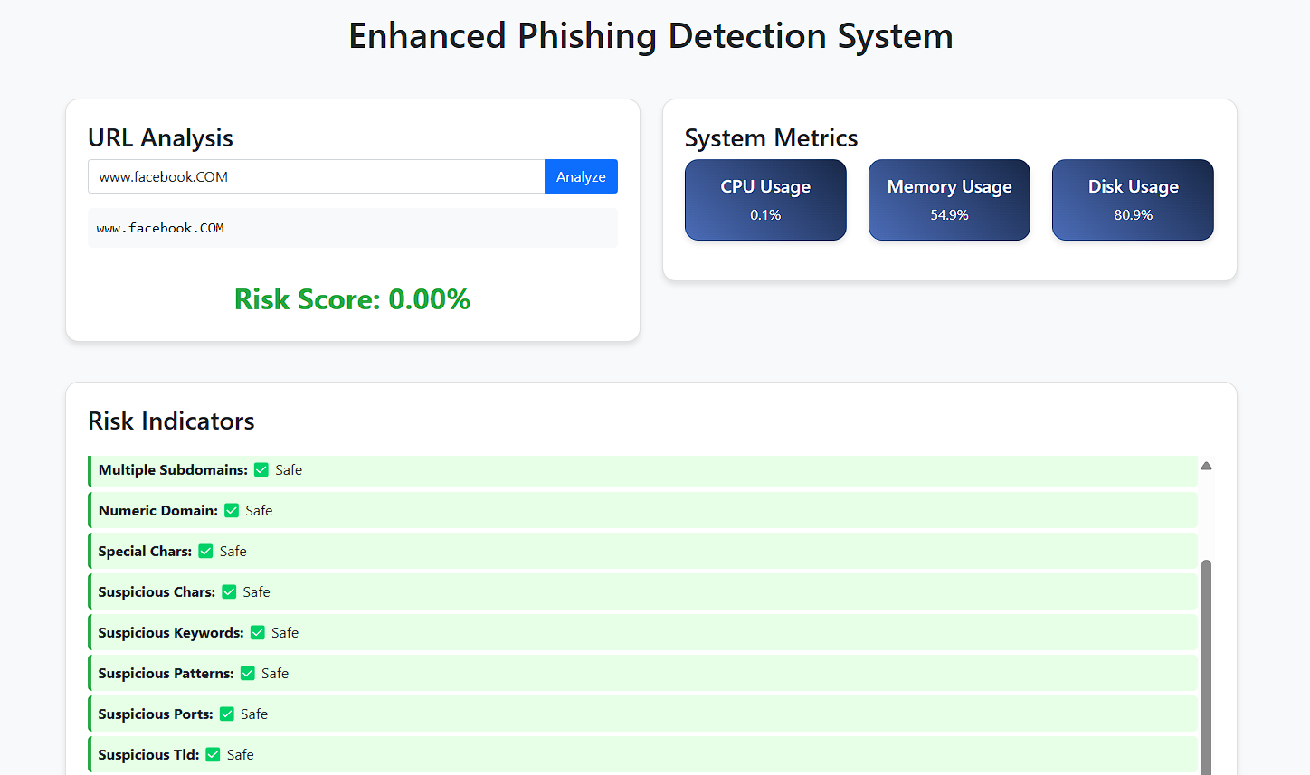

* 1. **-CPU&DISK RAM USAGE**

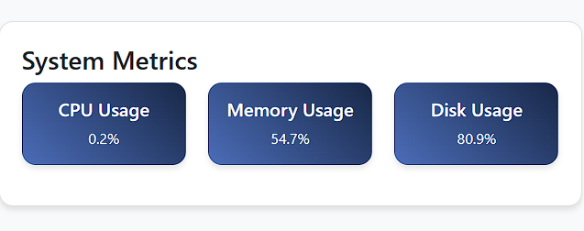

* 1. **CPU & DISK USAGE GRAPH**

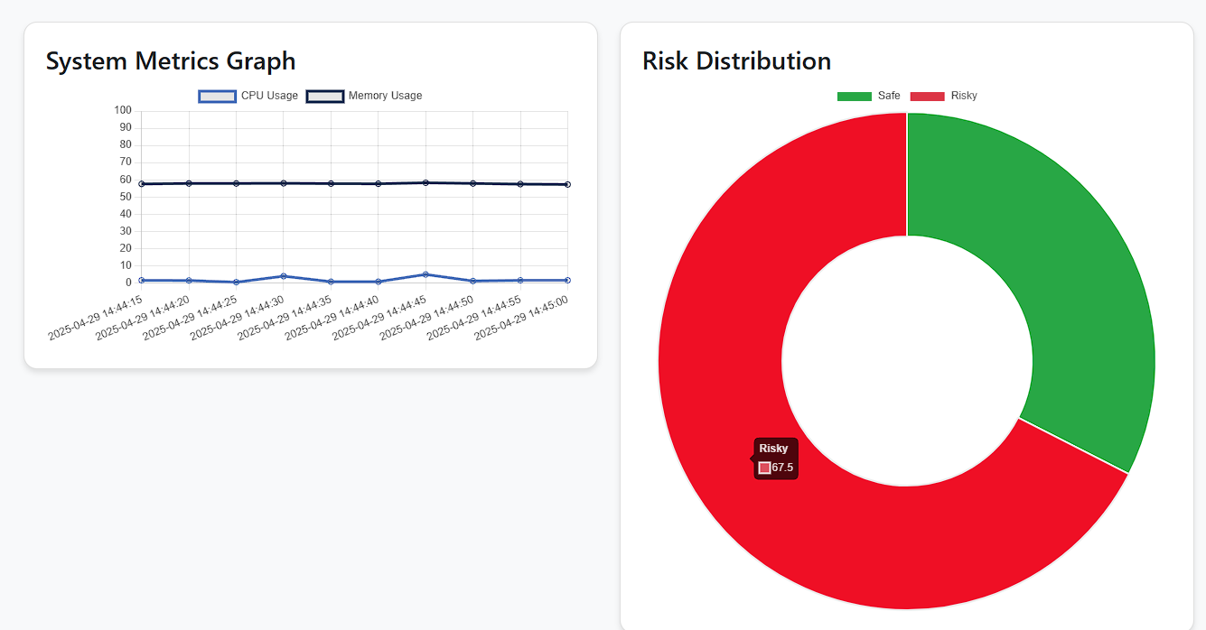

**CHAPTER 6 CONCLUSION AND FUTURE ENHANCEMENT**

# Conclusion:

This project provides an efficient rule-based system to detect phishing threats in real time. Unlike machine learning systems, this approach is lightweight, fast, and transparent in how it calculates risk. The integration of system monitoring adds an additional layer of awareness, allowing users to notice suspicious spikes in system behavior..

# Future Enhancements:

* Add real-time email phishing detection.
* Build a browser extension.
* Integrate blacklisted domain database.
* Add SMS (smishing) detection.

**CHAPTER 7**

**REFERENCES**

1. • **OWASP Foundation** – Phishing Detection Guidelines  
   https://owasp.org/www-community/phishing
2. • **Python Official Documentation** – Regex and URL Parsing  
   <https://docs.python.org/3/library/re.html>  
   <https://docs.python.org/3/library/urllib.parse.html>
3. • **psutil Documentation** – System Monitoring in Python  
   <https://psutil.readthedocs.io/en/latest/>
4. • **Flask Documentation** – Lightweight Python Web Framework  
   https://flask.palletsprojects.com/
5. • **Mozilla Developer Network (MDN)** – URL Structure and Security  
   <https://developer.mozilla.org/en-US/docs/Learn/Common_questions/What_is_a_URL>

.